Name:BuchupallePurnaTejeshwaraReddy Regno: 12401711
Roll no: 31 Ca2spmlab

HostelBookingapp
Fullganchatviewhaslinkagesfs,sf,ss,ffresolurcealsocation
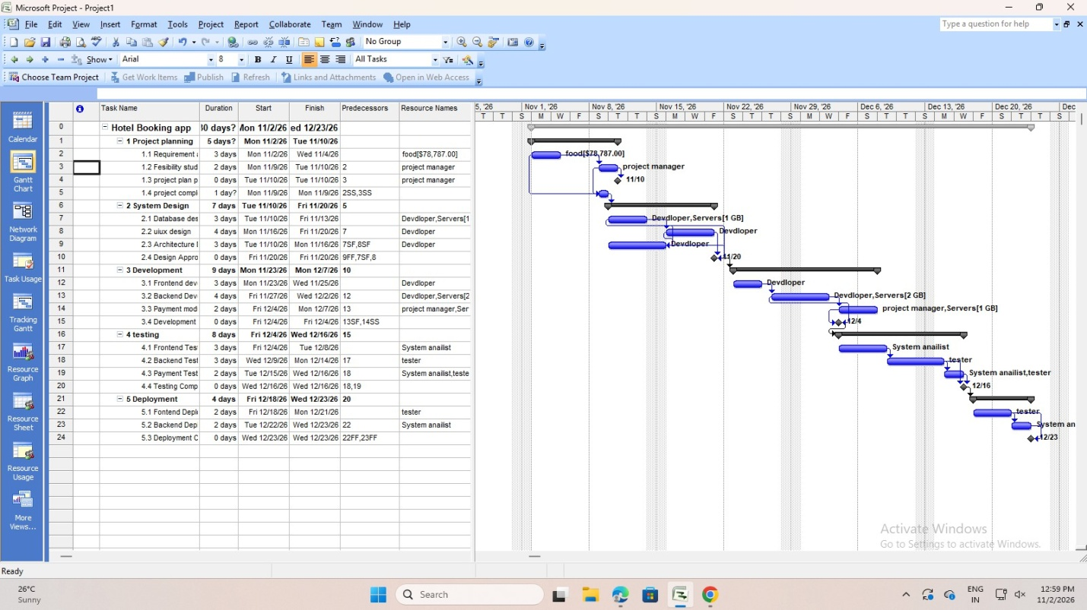
Ganchatview
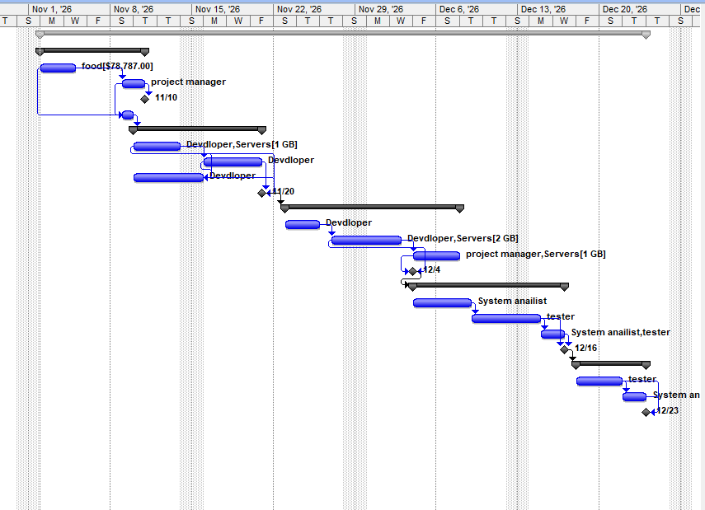

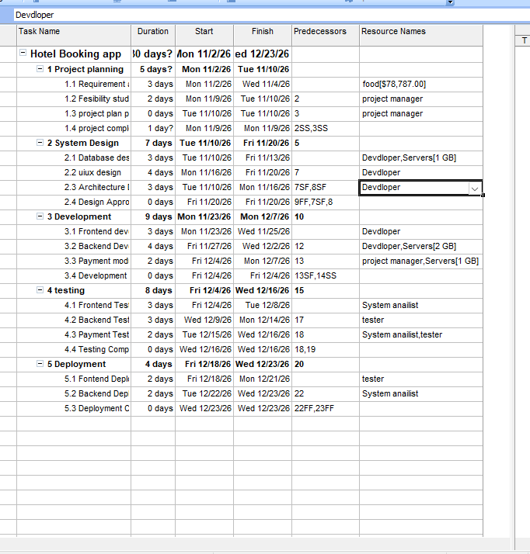
Holiday
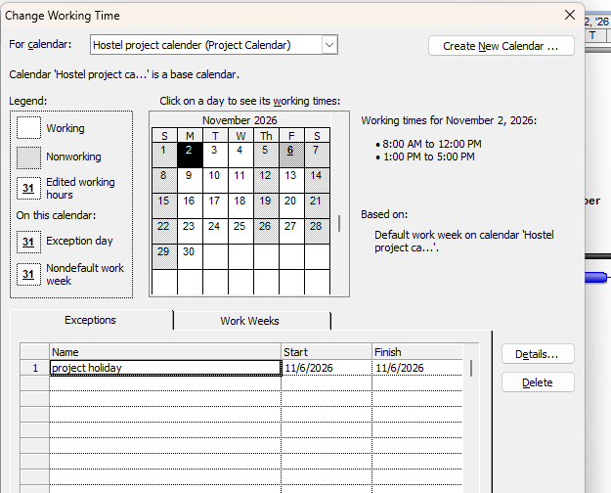

EveryThursdayisnonworkingDAY

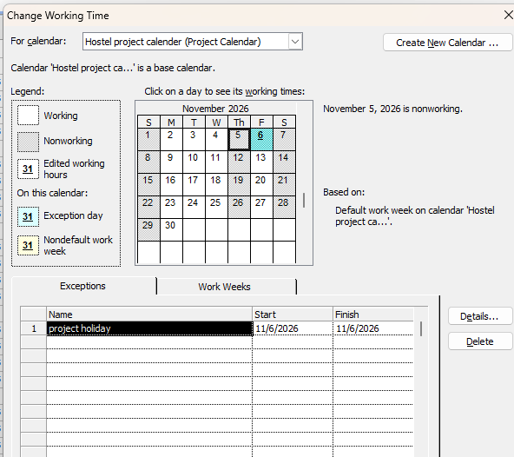
Resourcesheet
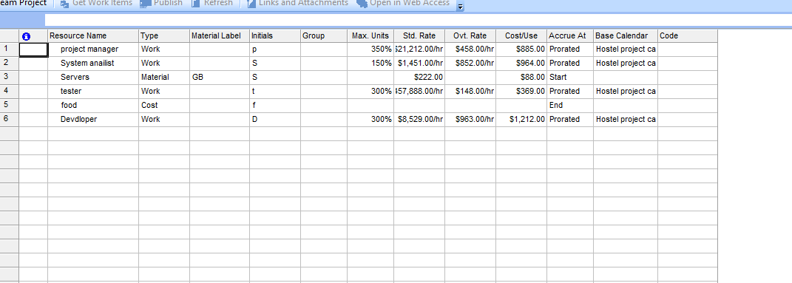
Network view
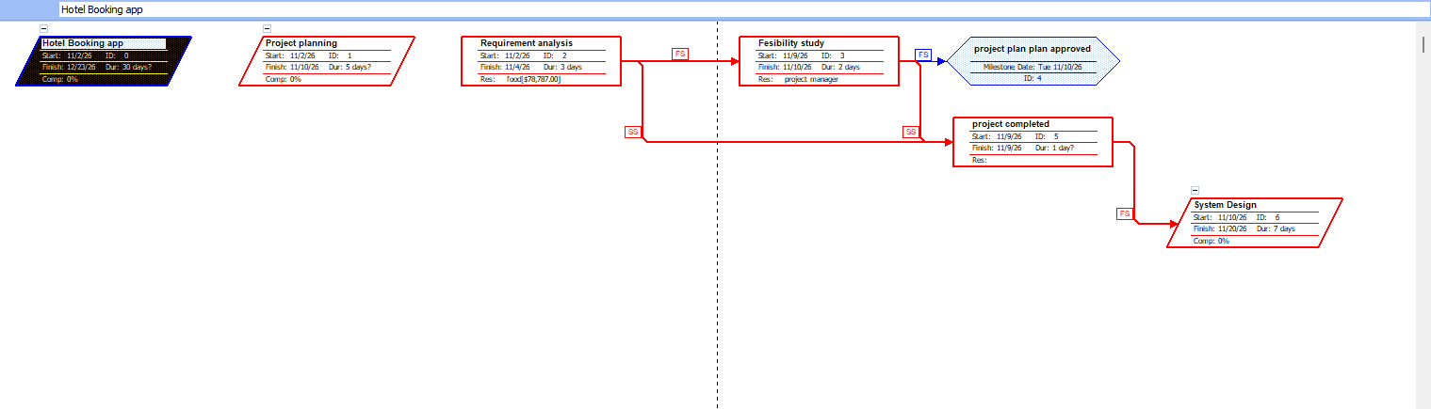

ALL resources can see hear : clickme

If not work

Use me : https://github.com/Purnatejeshwarareddyb/SPL-LAB-/tree/main/hostel%20booking%20app

